Mark was a devoted husband, father and friend that touched many lives through his enthusiasm and love of life. Every job, school, team or organization that he was involved with became a part of him. He had a great ability to connect with people and shared his passion for life with everyone that he met. As a father of a daughter with Rett syndrome, Mark did everything he could to make her life better. It is in his honor that we gather his family and friends to celebrate a life well lead and to give to a cause that was close to Mark’s heart.
Rett syndrome is a unique developmental disorder affecting cognitive, sensory, emotional, motor and autonomic function found most commonly in girls. Symptoms usually appear within 6-18 months, when there appears to be a slowing of skill acquisition followed by a period of regression. Rett syndrome presents itself differently in each individual. IRSF aims to fund research for treatments and a cure for Rett syndrome while enhancing the lives of those living with Rett syndrome by providing information, programs and services.
Please help us continue Mark’s efforts to support promising research into treatments and ultimately a cure for this devastating disease. Thank you for your support!

9th Annual
Mark Charamella Memorial Golf Outing and Dinner
May 9, 2022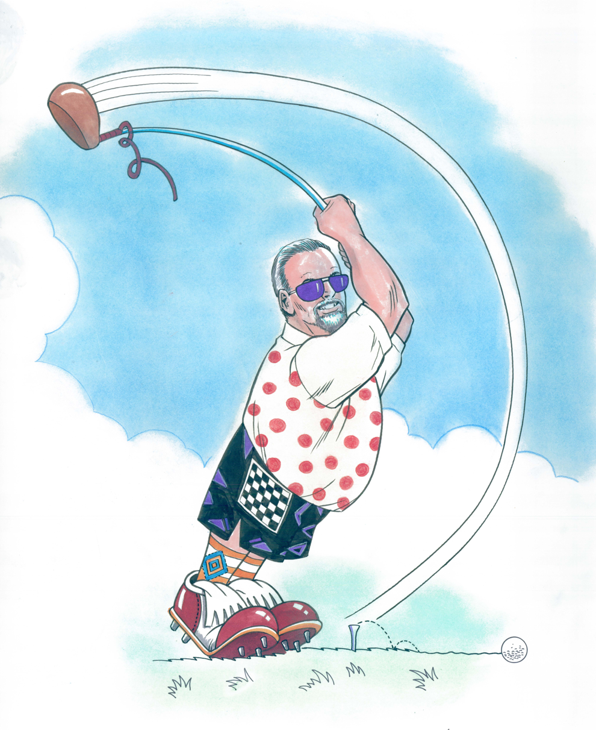
Benefitting
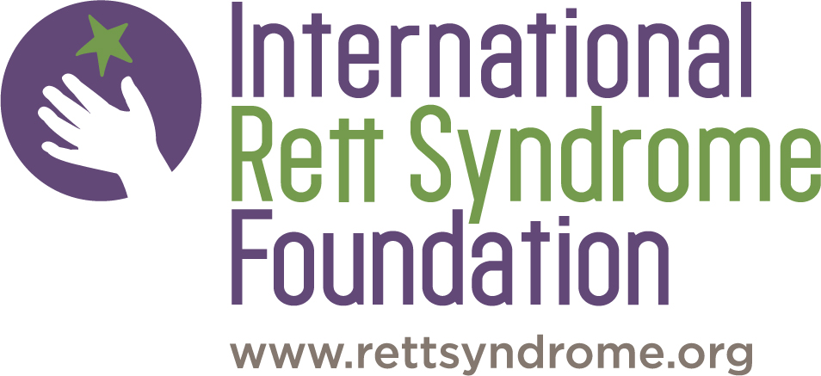

GOLF REGISTRATION
Name __________________________________
Company _______________________________
Address _______________________________
________________________________
E-Mail _________________________________
I will join for:
______ Golf (includes box lunch, golf & tailgate) x $125
_______ Tailgate (food truck dinner) x $50

GOLFERS: If you would like to register a pair or a foursome, please list your golf partner below and include their payment.

Golfer #2 Name: _________________________
Golfer #3 Name: _________________________
Golfer #4 Name: _________________________

FAMILY and CORPORATE SPONSORSHIP OPPORTUNITIES

Silver Sponsor $200
- Hole Sponsor
Gold Sponsor $400
- Hole Sponsor
- Facebook publicity

We are also accepting items for raffle and silent auction. If you have an item you wish to contribute please contact us.

Family/Company Name _________________________
Contact Person ________________________________
Email ________________________________________

Please check
- Silver
- Gold

ALL SPONSORS WILL NEED TO PROVIDE COMPANY LOGO/ARTWORK VIA EMAIL to Deb McLaughlin
markgolfrett@gmail.com

Please make all checks payable to
IRSF

Checks can be mailed to: Deb McLaughlin
ATTN: Golf Outing
419 Hawarden Rd
Springfield, PA 19064

ALL PAYMENTS & ARTWORK DUE
MAY 2, 2022
WESTOVER COUNTRY CLUB
401 South Schuylkill Ave., Jeffersonville, PA 19403
Box Lunch
18 Holes of Golf
Dinner – Tailgate
Golfer giveaway
Prizes, Raffle, Silent Auction

MONDAY MAY 9, 2022
11 – 12pm: Golf registration & Lunch
12:30pm: Shotgun Start
5pm: Tailgate, food truck

EVENT PACKAGES
Individual Golfer: $125
Includes box lunch, golf with cart, beer on the course, golfer giveaway & tailgate dinner
Tailgate only: $50 per person
Food truck dinner outside

About IRSF
IRSF is a national not-for-profit organization that channels over 90% of all net donations directly to program services. Your gift will be put to work immediately funding important research projects, family services and advocacy related to the treatment and cure of Rett syndrome.

IRSF is an accredited 501(c)(3) nonprofit agency; all donations are tax deductible.

